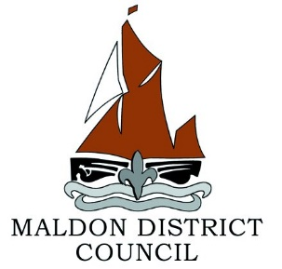

Maldon District Council Sandbag Policy 2025

Responsibility
The public has a general expectation that in a period of likely flooding Local Authorities will make sandbags available. This is not the case. Members of the public have a responsibility to protect their own properties. If their property is in a known flood plain or they consider they are at risk of flooding, they should purchase sandbags in advance from local building suppliers. Sandbags are not available from Maldon District Council.

Imminent flooding
If a property is at risk of being flooded, and where Emergency Services are in attendance and make a reasonable request for sandbags, the Council will, if stocks permit, respond.

Shops, Businesses and Commercial Properties
The protection of shops, businesses and commercial properties is the responsibility of the owners or occupiers. They should undertake their own risk assessment and make provision for the supply and positioning of sandbags.

Disposal of Sandbags
When sandbags are provided, they become the responsibility of the person receiving them. The Council will not accept liability for their placement; neither will the Council be responsible for collecting or disposing of issued sandbags.

Once used, sandbags are considered as contaminated material.

Note:
At times of actual or potential flooding owners of property look to ways that they might act to reduce the risks or impact on their property. The obvious quick fix is to try to prevent the ingress of water by providing a barrier of sandbags either around their property or at the portals to their buildings. Sandbags can be useful to deflect a flow of water but are not waterproof and therefore are generally ineffective in preventing standing water from entering a building. Water will also seep through the ground, airbricks and the brickwork itself. Caution must be exercised in using sandbags as differential water levels between the inside and outside of a building can induce structural failure.

Before any actual flooding is threatened property owners should undertake a risk assessment and source appropriate property level flood risk mitigation systems, such as air brick covers and flood door barriers.

The Blue Pages provides information on property level flood protection products and services available to help reduce the risk of flooding to your home or business.
https://bluepages.org.uk/

