

Asset Management Strategy 2024-2029

Document title | Asset Management Strategy
Prepared by | Katy Moore / Steven Butcher
Status | Approved
Version number | V1.0
Approved by | Council
Approval date | 21st March 2024
Date of implementation | May 2024
Review frequency | 5 years
Next review date | March 2029
Circulation
Published on the Council’s website | TBC

Validity Statement

This document is due for review by the date shown above, after which it may become invalid. Users of the strategy or policy should ensure that they are consulting the currently valid version of the document.

TABLE OF Contents
1. Asset Management Strategy Context 3
2. Asset Management Strategy Purpose 3
3. Asset Management Strategy vision 4
4. Asset Management Strategy Objectives 4
5. Asset Management Strategy scope 4
6. Asset Management Strategy Governance Structure 4
7. Asset Management Strategy Implementation 7
8. Asset Management Evaluation 8
9. Circulation and Review / Sign off 9
10. Document Version Control 9
11. References and Supporting Documentation 10

Asset Management Strategy Context
  - The Council’s estate is made up of a diverse range of assets including land, buildings and parks and open spaces, as detailed in the Council’s Asset Register.
  - The Council also owns around 130 assets that are under lease or licence to commercial or community partners; and 70 moorings and berths throughout the Blackwater.
  - The condition of the Council’s assets varies, with some assets being well maintained, whilst others have suffered in recent years due to financial and resource constraints.
  - Whilst health and safety and other statutory considerations are the Council’s first priority, additional investment to maintain and enhance Council assets is under greater strain. This Strategy is intended to be the catalyst to undertake a detailed review of the Council’s assets to consider how it can best address these issues, whilst also contributing to the Council’s broader strategic objectives.
  - The Council will need to continue to transform and evolve as it seeks to deliver services under greater financial pressures. The Council has to balance its core requirements for physical assets to deliver services, with its other strategic objectives. The aim of this Strategy is to improve utilisation of the estate, rationalise operational use where appropriate, and make cost savings and/or improve income generation.
  - Historically the Council’s approach to commercial and investment opportunities has been to consider opportunities as they arise, rather than adopting a more strategic approach to asset acquisition, development, and disposal. This Strategy aims to establish a framework to determine the Council’s priorities for its key assets to enable it to act it a more pro-active capacity towards commercial opportunities.

Asset Management Strategy Purpose
  - Physical assets form the foundation on which the Council delivers its services. They play a key role in shaping the social, environmental, and economic wellbeing of the local community, influencing the quality of life for local people.
  - Maldon District Council’s Asset Management Strategy sets the strategic framework for the Council’s estate operations, over the next five years. It is intended to guide future decisions regarding the strategic needs of the Council concerning the acquisition, use and disposal of estate assets (property and land) and to ensure that the assets are fit for purpose, efficient and financially viable. The Strategy sets out the governance approach that will support decision making for both new initiatives and day to day management of the estate.
  - This Strategy also sets out the approach that Maldon District Council will take towards physical assets that it shares with strategic and community partners.

Asset Management Strategy Vision
“To ensure that the Council’s assets continue to meet its own strategic, operational, and financial objectives, as well as those of its partners, residents and visitors, through optimising asset performance, sustainability, and cost effectiveness across its estate.”

Asset Management Strategy Objectives
  - The core objectives of this Asset Management Strategy are to:
- Optimise the contribution that property and land assets make to successfully realising the Council's strategic priorities and service objectives by ensuring that it its estate is fit for purpose, financially viable and operationally sustainable.
- Reduce the environmental impact of Council owned assets to contribute to carbon neutrality.
- Improve asset income by taking measured risks with regards to property repurposing, investment, and disposal. This includes reducing running costs by improving building efficiency.
- Act upon strategic acquisition opportunities where these are affordable and align with corporate objectives e.g. affordable housing.
- Establish a robust asset appraisal system that will be undertaken throughout the life cycle of this Strategy to aid strategic decision making.

Asset Management Strategy scope
  - The scope of this asset management strategy will cover three key areas:
- Development / maintenance of existing Council owned land and property*
- Disposal of surplus assets
- Acquisition of new property / land assets to deliver Council objectives, where affordable

*Car Parks on council owned land are currently under separate review with a specific Car Parking Strategy being developed to look at opportunities for investment, development, and technology initiatives in the future.

Asset Management Strategy Governance Structure
  - Officers
    - Under the Council’s constitution some assets management decisions are delegated to officers.
    - Currently lease agreements can be made under officers’ delegation up to seven years, with a value of up to £15,000.
    - Longer leases can be agreed in consultation with the Leader of the Council and Chairperson of the Strategy and Resources Committee these delegations can be increased up 14 years and up to a value of £25,000 per annum.
    - For any decisions that exceed these delegations, Member working groups are engaged to provide direction. with formal decisions then progressed to the Strategy and Resources Committee and/or Council for decision (as set in the structure diagram below).
    - It is proposed that the delegations pertaining to the management of assets are reviewed to allow quicker, less bureaucratic decision making for low value lease agreements.
    - The Asset Strategy seeks to categorises officer activity into two distinct areas:
- Strategic Asset Management
- Operational Delivery
    - These categories identify areas of focused activity and are grouped to allow for clear and consistent management, reporting and decision making. The key activities for each area are shown in the governance structure below:
  - Members
    - The proposed Asset Strategy Governance Structure set out below recommends that the existing Corporate Projects Working Group (CPWG) and Asset Management Working Group (AMEG) are replaced with one working group; called the Strategic Assets Working Group reporting into Strategy and Resources Committee (subject to agreement by the Council in May 2024). This will remove potential duplication/overlap across the existing working groups and allow for a more efficient process.

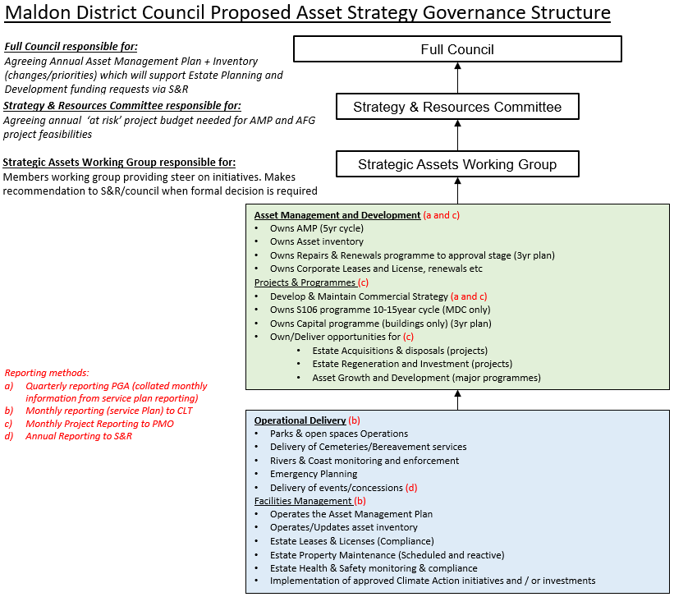

Asset Management Strategy Implementation
  - Given the substantial number of assets that the Council holds it will not be possible to review these all within the five-year Asset Strategy duration.
  - Therefore, consideration will be given to prioritising which assets should be reviewed in more detail to progress to business case stage.
  - An initial prioritisation exercise will be conducted by officers, in conjunction with the Strategic Assets Working Group, to draw up a five-year Asset Management Plan which will be presented to the Strategy and Resources Committee for approval. This will be reviewed and reported on an annual basis.
  - It is proposed that the criteria for initial prioritisation should be as set out below:

Proposed criteria for initial prioritisation of asset reviews:
- Any assets that are known to pose an immediate Health and Safety risk
- Asset overall balance sheet value
- Strategic importance to delivery of core Council services
- Strategic importance to delivery of key partnerships
- Potential to generate income and/or revenue saving.

  - Delivering against the framework.
    - Officers will report regularly to the Strategic Assets Working Group on asset management activities.
    - Business cases will be appraised by the Corporate Leadership Team via the Programme Management Office (PMO) Project Board before a recommendation is made to the Strategic Assets Working Group. This will include identification of the resources required to deliver the business case and any ongoing cost implications.
    - Capital investment bids for improvement / development will normally be progressed as part of the annual budget setting process unless a commercial opportunity is agreed to be pursued outside of this process.
    - Repairs and maintenance budgets will also be agreed as part of the budget setting process unless urgent health and safety measures are required outside of this process.
  - Approach to collaborating with partners:
    - Whilst the Council continues to recognise the wider community value and social outcomes delivered by partners, a consistent and fair approach should be taken on the use of Council owned assets to ensure value for money can be demonstrated.
    - Partners who are using Council owned assets at discounted rates will therefore be asked to evidence how they contribute to the Council’s corporate goals on an annual basis. This evidence will be considered by the Strategic Assets Working Group who will make recommendations to the Strategy and Resources Committee as appropriate.
    - The Council policy is that it will no longer subsidise utility expenses on its assets. These must be paid in full by the lease holder.
    - Arrangements will be made to meet local and regional partners to discuss strategic asset management matters and opportunities on a regular basis. Where possible the Council will align its working relationships to deliver “one public estate” outcomes for the financial benefit of ourselves and partners, or improved customer services.

Asset Management Evaluation
  - As each asset is assessed the aim is to establish an improved evidence base which can be used to determine a ‘Whole Life Costing’ over the assets useful life to ensure it delivers value for money. Qualitative as well as quantitative aspects will be considered to build a full picture. The size and type of the asset this will determine the level of business case required. The following data will be captured to ensure robust recommendations and decision making can be made.
- Asset Location
- Current balance sheet value
- Estimated Useful Economic Life (UEL)
- Asset current condition and estimated future maintenance costs
- Running costs
- Health and Safety compliance
- Sustainability / environmental credentials e.g. carbon footprint
- Asset current utilisation / vacancy rates
- Fitness for purpose in current use
- Development opportunities
- Community value delivered aligned with Council corporate objectives

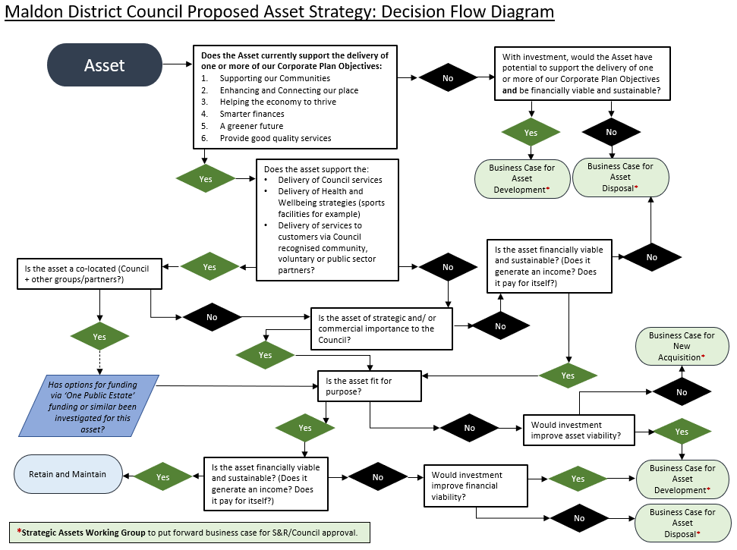

Circulation and Review / Sign off

Name | Role | Directorate | Signed off
Naomi Lucas | Chief Finance Officer | Resources | 04/03/2024
Paul Dodson | Director of Strategy and Resources | Strategy, Performance and Governance (SPG) | 04/03/2024
Richard Holmes | Director of Service Delivery | Service Delivery | 04/03/2024

Document Version Control

Date (YY/MM/DD) | Version | Details | Changes
29/02/2024 | 0.1 | DRAFT | Issued for approval
14/03/2024 | 0.1 | Approved at S&R – Council to ratify on 21/03/24
21/03/024 | 1.0 | FINAL – Council approved

References and Supporting Documentation
Maldon District Council (MDC) Assets Register: hosted within uniform software, accessible as and when required.

