THE LOCAL DEVELOPMENT PLAN SETS OUT TO DO
1.0 Introduction

1.1 This fact sheet addresses the monitoring of the policies which cover design and climate change. These are D1 Design and Built Environment, D2 Climate Change & Environmental Impact of New Development, D3 Conservation and Heritage Assets, D4 Renewable and Low Carbon Energy Generation, D5 Flood Risk and Coastal Management and D6 Advertisements.

2.0 D1 Design and Built Environment and D6 Advertisements

2.1 This policy sets out the main design principles that development in Maldon District should conform to. The Maldon Design Guide was completed in 2017. Policy D1 is the policy that has been most used in appeal decisions (in 61 out of 87 appeal decision notices) and inspectors have consistently found that it is in conformity with national planning policy.

2.2 In 2021/21 there were no planning appeals that referred to Policy D6.

3.0 D2 Climate Change & Environmental Impact of New Development
3.1 This policy sets out how development should minimise its impact on the environment. Policy D2 has been used in appeal decisions and inspectors have found that it is in conformity with national planning policy.
4.0 D3 Conservation and Heritage Assets
4.1 In 2021 there are seven heritage assets at risk in Maldon District. This is an increase of 1 from 2019. The assets are as follows;
- Creeksea Place, Ferry Road, Creeksea – Elizabethan courtyard house.
- Former Stow Maries Airfield, Flambirds Farm, Stow Maries, Cold Norton – WW1 Flying Corp airfield.
- Plume Library, High Street, Maldon (new on the Heritage at Risk Register).
- Wickham Bishops Timber Trestle Railway Viaduct.
- Mill Mound (SAM), Beckingham Hall, Tolleshunt Major.
- Woodham Walter Hall (SAM and LB) early 16c house and garden earthworks.
- Stow Maries WW1 aerodrome – conservation area.
Source: https://historicengland.org.uk/images-books/publications/har-2021-registers/
5.0 D4 Renewable and Low Carbon Energy Generation
5.1 The District has made some inroads into renewable and low carbon energy delivery since the LDP was adopted in 2017, although overall kilowatt output had fallen in 2018 and 2019, output increased in 2020 . Latest information from the Department for Business, Energy and Industrial Strategy for Maldon District includes the following;

YEAR | PHOTOVOLTAIC | WIND DEVELOPMENT | TOTAL SITES | TOTAL KILOWATTS
2020 | 1,304 | 22 | 1326 | 200,355.702
2019 | 1289 | 22 | 1311 | 166,814
2018 | 1,231 | 22 | 1253 | 166,848
2017 | 1186 | 23 | 1209 | 171,219

Source: Renewable_electricity_by_local_authority_2014_to_2020_rev.xlsx (live.com)

6.0 D5 Flood Risk and Coastal Management

6.1 As a low-lying coastal authority, parts of the District are potentially at risk from fluvial and tidal flood risk, and from coastal erosion. The impact of coastal erosion and flooding needs to be carefully managed in relation to existing properties and future development.

6.2 The Council has through its development management process successfully steered inappropriate development away from areas of high flood risk and has had no applications called in by the Environment Agency because of an issue with conformity and national policy.

7.0 Maldon District Design and Conservation Awards
7.1 The Maldon District Conservation & Design Awards have been running for 38 years.

7.2 In 2021 Goose House, Woodham Mortimer won the Design Award. The site is sensitive; formerly part of the farmyard of Woodham Mortimer Place, surrounded by historic and listed buildings and mature trees. The brief was to provide a highly sustainable home for the owner of an adjacent grade II listed house, Crodon’s Barn, to allow him to continue to live on site. By raising the house onto a steel deck, it was possible for the building to wrap around an ancient oak tree, ensuring no damage was done to the tree roots. This approach also made it possible to retain two old timber-framed outbuildings either side of the new build. The walls feature multi-coloured ‘slots’ visible between vertical larch boards, giving the building a playfulness but also reflecting the colours of leaves through autumn and woodland flowers in the summer. The timber frame of the building uses deep timbers to allow for very high levels of insulation. The internal polished concrete floor finishes provide a large radiant surface for the underfloor heating system which is connected to an air-source heat pump. The house and its glazing have been oriented to maximise solar gain in winter months, whilst the canopy of trees reduces this is summer.
Goose House, Woodham Mortimer
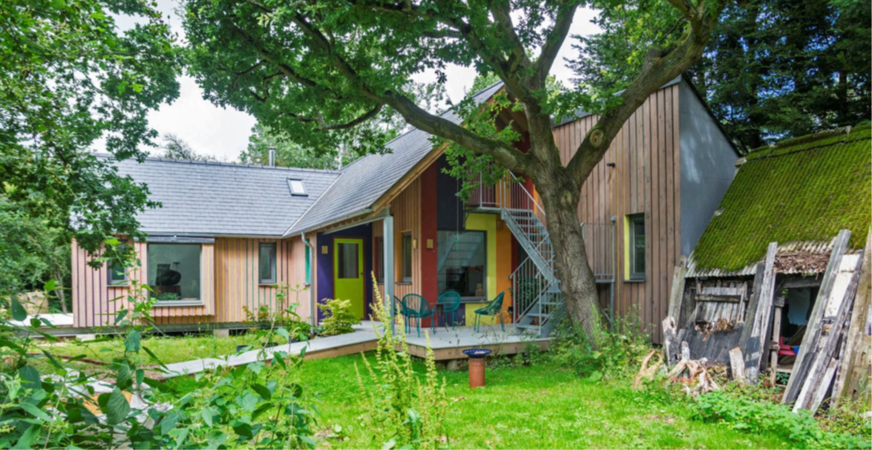
© Annabel Brown
7.3 The Building Conservation Winner was Creeksea Place, Burnham-on-Crouch. This award is for the repair of Creeksea Place, a grade II* listed building and one of the most important Elizabethan houses in this part of Essex. It was built of red brick in the late 1560s, partially demolished in the 18th century, and then restored and extended in the early-20th century. Following requisition by the army during WWII, the house suffered a long period of neglect. Leaking roofs caused extensive timber decay throughout the oldest part of the building, and in 1993 the house was added to the Register of Heritage at Risk. Props had to be installed to prevent parts of the roof and floor structure from collapsing, rendering much of the interior unusable. Use of parts of the building in recent years as a wedding venue successfully financed general maintenance but never generated enough funds to tackle the major repairs required. Historic England assisted with grant funding towards the most the most urgent repairs needed to the original wing, which began in January 2020. This work included substantial repairs to the roof, brickwork, chimney stacks, rainwater fittings, windows, internal floors and historic oak panelling in one of the main bed chambers. The judges were extremely impressed by the sheer extent of this major repair project. Creeksea Place is an exceptionally important building for the Maldon District and the judges agreed that every encouragement should be given towards putting the building back into full use.

Creeksea Place, Burnham-on-Crouch
© Tim Howson

8.0 Conclusion
8.1 With regard to the design and climate change policies within the plan, broadly they have been successful in ensuring that development is of a high quality in appropriate places across the District in line with the LDP. KEY

More information: www.maldon.gov.uk This document is available in different formats on request

