THE LOCAL DEVELOPMENT PLAN SETS OUT TO DO
1.0 Introduction

1.1 This fact sheet addresses the monitoring of the policies which cover the natural environment, green infrastructure, transport and access. These are policies N1 Green Infrastructure Network, N2 Natural Environment, Geodiversity and Biodiversity, N3 Open Space, Sport and Leisure, T1 Sustainable Transport and T2 Accessibility.

2.0 N1 Green Infrastructure Network

2.1 This policy supports a multi-functional network of green spaces. Development which results in the creation, restoration, enhancement, expansion and interconnection of these sites will be encouraged. Set out in Table 1 below are the allocated Strategic Sites and Garden Suburbs. All those sites which have received planning permission have provided green space and formal open space with some allotment provision.

LDP REF NO. | LOCATION | STATUS (AS OF 18-5-2022) | PROVISION OF GREEN SPACE/PLAY/COMMUNITY FACILITIES
S2(a) | South of Limebrook Way, Maldon – eastern parcel | Detailed permission for 606 dwellings. Eastern parcel. Under construction. | Formal open space including allotments, Local Area for Play (LAP), neighbourhood equipped area for play (NEAP), local equipped area for play (LEAP), junior football pitches and ancillary changing rooms.
S2(a) | South of Limebrook Way, Maldon – western parcel | Phase 1 dwellings under construction, 273 units built as of 31st March 2022. Reserved Matters application for phase 2 granted January 2022. | These provisions are linked with the eastern parcel of land above
S2(b) | Wycke Hill North, Maldon | Outline permission granted 2020 subject to S106. | Public open space, allotments, LAP, LEAP, NEAP, contribution for Youth facilities.
S2(c) | Wycke Hill South, Maldon | Complete | 0.13 hectares of open space
S2(d) | North of Heybridge | Works have started on site June 2022 | Informal and formal public open space including children’s play areas, allotments, sports playing fields, youth facilities, children’s play areas
S2(e) | Land North of Holloway Road Heybridge | Complete | Public open space
S2(f) | West of Broad Street Green Road, Heybridge | Under construction, near completion. | 21 hectares of green space and public open space, contribution towards LEAPS and NEAPS within the Heybridge Garden Suburb, contribution toward allotments, contribution toward Youth facilities.
S2(g) | Park Drive, Maldon | Completed | Public open space
S2(h) | Heybridge Swifts, Heybridge | Without planning permission | N/A
S2(i) | West of Burnham-on-Crouch | Full planning permission; under construction | Approximately 5 hectares of green infrastructure including public open space, planted areas and footpaths. 2 local equipped play areas (LEAPs) and allotments. There is also a financial contribution toward youth facilities.
S2(j) | North of Burnham-on-Crouch (west) | Complete | Public open space with footpaths, 1 LEAP and 1 NEAP, allotments and a contribution toward youth facilities.
S2(k) | North of Burnham-on-Crouch (east) | Planning application approved December 2020, works started on site in 2021. Twelve units completed. | Public opens space.

DATE OF APPROVAL | ADDRESS | STATUS OF SITE | PROVISION OF GREEN SPACE/PLAY/COMMUNITY FACILITIES
1/3/2019 | Land west of Cemetery Chapel, Southminster Road, Burnham on Crouch | Works started on site; six units completed. | Public open space with planting and footpaths and a LEAP.
1/5/2017 | Land to east of Pippins Road, Burnham on Crouch | Complete | Public open space
14/10/2020 | Land northwest of 2 Maldon Road, Burnham on Crouch | Reserved Matters approved and started on site | Amenity and sports facilities, allotments, public open space, LEAP, medical facility, ancillary community centre.
19/2/2019 | Land west of Bridgemans Green, Latchingdon | Reserved Matters approved, LDP sought under application 22/00592/LDP for lawful commencement – application currently invalid. | Public open space
7/2/2019 | Land north of Latchingdon Bowls Club, Burnham Road | Full permission. NMA and VAR applications have been received under references 22/00568/NMA, 22/00569/NMA, 22/00589/VAR  22/00590/VAR | Public open space, village hall.
29/5/2019 | Land west of Fambridge Road, North Fambridge | Reserved matters approved. 43 units completed. | Public open space, village green
29/1/2016 | Manor Farm, The Avenue, North Fambridge | Reserved matters approved | Public open space

3.0 N2 Natural Environment, Geodiversity and Biodiversity

3.1 Policy N2 seeks to protect international and national designations in accordance with the European Habitats Directive (92/43/EEC) and the Conservation of Species and Habitats Regulation (2010). It also seeks to protect locally designated sites. At the present time, there is no monitoring framework in place to monitor this policy. A summary of the information available on the LDP indicators for policy N2 is given below:

Table 2: Condition of Nationally and Internationally designated sites

Name of site | Area (ha) | Latest assessment date | Condition Summary
Blackwater SSSI  NNR  SPA  Part of Essex Estuaries SAC | 4403.5 | SSSI made up of 88 units - majority last surveyed in 2010:  Unit 05 28/10/21  Unit 16 06/08/21  Unit 33 20/7/21  Unit 34 & 35 17/7/21 | 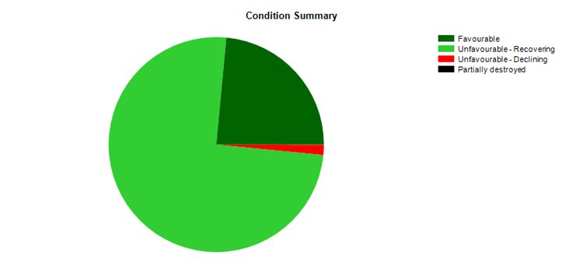
Crouch and Roach Estuaries SSSI  SPA | 1847.9 | SSSI made up of 60 units – majority last surveyed 2010-2013  Unit 15 01/12/2021 | 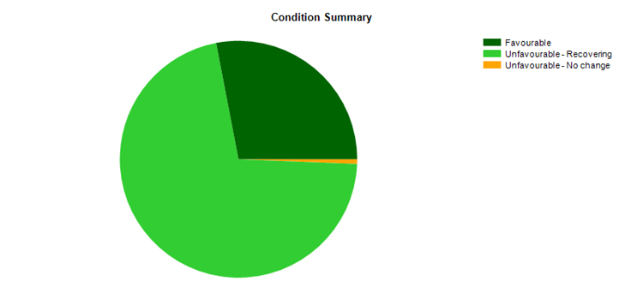
Dengie SSSI  NNR  SPA  Part of Essex Estuaries SAC | 3132.4 | Site made up of 8 units. Majority last surveyed 2012-2014  Units 01-03 18/12/2020 | 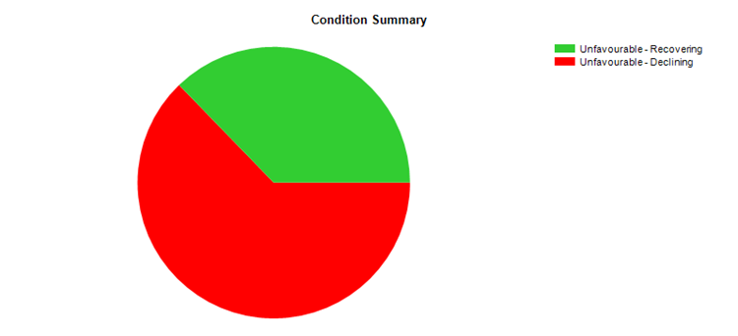
Goldsands Road Pit | 1.15 | 21/3/2012 | 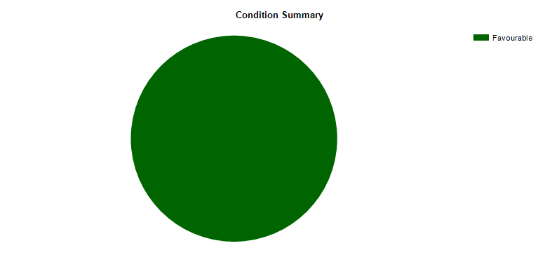
Lofts Farm Pit | 4.9 | 26/11/2010 | 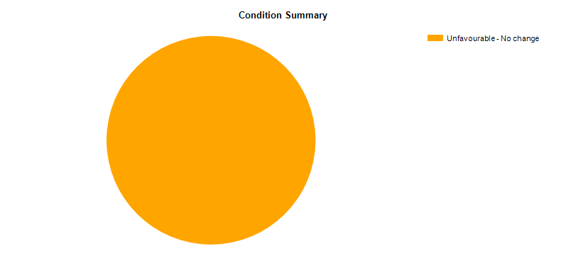
Maldon Cutting | 0.16 | 30/03/22 | 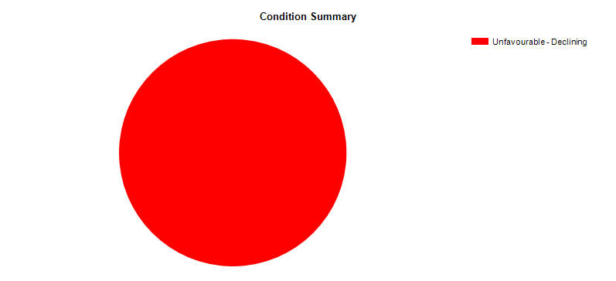
Sandbeach Meadows | 29.4 | Site made up of 2 units  30/10/2009
The Cliffe Burnham-on-Crouch | 3.8 | 20/11/2021
Tiptree Heath (majority is within Colchester Borough Council area | 24.5 | 24/3/2010 | 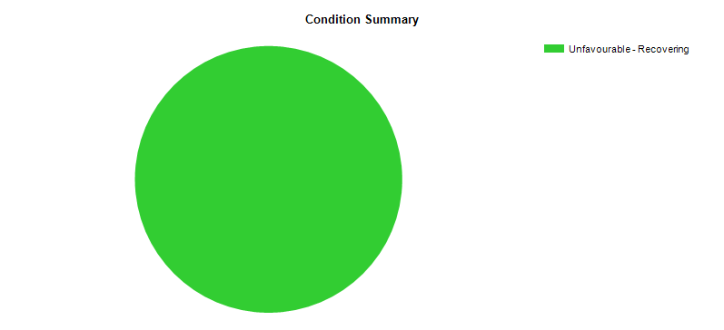
Woodham Walter Common | 79.7 | Site made up of 9 units  25/11/2009
Source: Natural England Designates Sites View - https://designatedsites.naturalengland.org.uk/

Table 3: Locally designated sites and BAP Species and Habitats

Category | History | 2022 update
Local Wildlife Sites (LoWS) | Maldon District Nature Conservation Study 2007 surveyed and identified 60 LoWs which are identified in the  LDP 2017. | 2022 – A new Nature Conservation Study is being undertaken during 2022. The LoWS are being reviewed as part of this study. The final report will be included as part of the evidence base for the LDP Review
BAP species | 2011 Essex Biodiversity Action Plan (A Wild Future for Essex) identified a large number of species and habitats on which to focus action. Species and habitats that occur in Essex were selected from a national list of plans, together with some extra ones that are characteristic or indicative of the Essex countryside. | 2022 - The Nature Conservation Study will identify BAP species and habitats of particular importance to the District.

Essex-wide great crested newt District Level Licencing
3.2 The Essex-wide great crested newt District Level Licencing (DLL) scheme has been running since 2020, it was recently renewed for another 2 years. DLL is a strategic approach to licensing for great crested newts (GCN), sponsored by Natural England. Traditional mitigation licensing requires on site mitigation measures to be carried out. These can delay development as some measures can only be carried out at certain times of the year. DLL does not require on site mitigation; instead, developers make a payment based on the impact of their development. This conservation payment is used to create compensatory habitat off-site, which is targeted to areas where it will most benefit GCN- making bigger, better and more joined up habitats. The benefits of the scheme for GCN are:

- Bolsters existing newt populations while improving range and connectivity
- Populations are more resilient to external pressures
- Ponds are maintained and monitored in the long term, helping us better understand population conservation science
- As part of DLL, the largest ever survey of its type for GCN across England has been completed and the results are open to all

3.3 So far, 116 compensation ponds have been created or restored in nine Essex local authority areas, including Maldon District. The infographic below summarises the results of the first two years of the scheme.

Infographic: Results of the first two years’ operation of the Essex District Level Licencing scheme
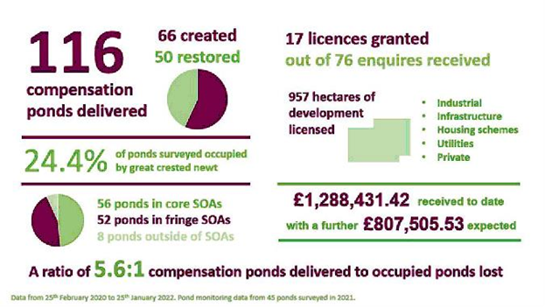
© Natural England

Essex Coast Recreational Disturbance, Avoidance and Mitigation Strategy
3.4 On the 6th August 2020, the Council adopted the Essex Coast Recreational Disturbance, Avoidance and Mitigation Strategy Supplementary Planning Document (or RAMS SPD). The RAMS SPD focuses on the mitigation that is necessary to protect the wildlife of the Essex coast from the increased visitor pressure associated with new residential development in-combination with other plans and projects, and how this mitigation will be funded. The RAMS SPD sets out the guidance to be followed in the determination of planning applications and formalises the arrangements for securing the developer contributions for new qualifying residential development. The Council collects RAMS contributions for residential development within the District via Unilateral Undertakings. These are pooled across all of the affected Essex authorities and fund measures to mitigate the impact on the coastal locations.

Maldon District Conservation and Design Awards
3.5 The Maldon District Conservation and Design Awards has been running for 38 years. In 2021, Lauriston Community Farm in Goldhanger won the Nature Conservation Award. This award is for a uniquely conservation-focussed 210-acre farm on the Blackwater Estuary. The farm is community owned with 214 people holding community shares in it, 90% of whom live within Essex. Training, work experience and day placements are integrated into the daily farm work for people with learning disabilities and/or autism. The site is a Site of Special Scientific Interest (SSSI) and falls within the Blackwater Estuary RAMSAR designation. The farm is managed for wildlife and food production. All the land is certified biodynamic organic so the soil is very healthy and there is no chemical run off. The health of the farm is demonstrated by the nesting presence of many birds of prey – marsh harrier, kestrel, sparrow hawk, barn owl, tawny owl and little owl. Breeding sites are provided for rare estuarine birds (including lapwing, snipe, and redshank), other rare species include skylarks and turtle doves, and around 2,000 brent geese overwinter on the grassland every year.

3.6 Since 2006 around 5,000 hedging plants have been planted and next year a further 3ha of scrub will be developed for turtle dove nesting. The farm also manages grassland for insects and the shrill carder bee and many butterflies and moths have been recorded on the site.

3.7 The judges were extremely impressed by this project, for its outstanding nature conservation credentials, the inclusion of people with learning disabilities or autism and for the commitment and vision of those involved. The judges were particularly struck by the preservation of a remarkable example of historic saltmarsh meadow which retains the undulating profile of the salt marsh and is used as grazing for Shetland cattle.

Photo: Lauriston Community Farm
© Lauriston Farm Ltd
https://www.maldon.gov.uk/info/20049/heritage_and_conservation/9669/conservation_and_design_awards_winners

4.0 N3 Open Space, Sport and Leisure
4.1 As can be seen from Table 1 above, at paragraph 2.1, on the allocated Strategic Sites, Garden Suburbs and other major housing developments granted permission since 2016, open space and sport provision is being brought forward which is in line with the direction of policy N3 in that in principle, development must contribute towards improving the provision, quality and / or accessibility of local and strategic open space, sports, and associated community and leisure facilities.
4.2 Adult participation in sport can be monitored broadly from Sport England`s Active Life yearly survey. Between May 2020 and May 2021 there were 420 respondents to the survey for Maldon and 62.6% of those residents stated that they had been active for more than 150 minutes a week, 13% stated that they had been fairly active and 24.4% stated they were inactive. These figures show there has been a decrease in the number of active respondents compared to the previous 12 months, likely related to Covid 19 restrictions.
5.0 T1 Sustainable Transport and T2 Accessibility
5.1 Both policies T1 and T2 seek to promote sustainable, accessible transport for the District and a built environment that is accessible for all. In terms of rail within the District only the Crouch Valley Line which runs from Wickford to Southminster remains – which is a single track branch line, with a passing loop at North Fambridge, but this does provide an alternative to those wishing to travel other than by bus or car. Rail usage is monitored by the Office of Rail and Road and in Table 4 below are the user figures for the rail stations in Maldon District. Usage has declined since 2016/17. The Covid-19 pandemic has had a dramatic effect on rail usage nationally and within the District during 2020/21 – with station entries and exits falling by 83% for Burnham -on-Crouch compared to 2018/19.
Table 4 Station entries and exits for train stations in Maldon District
Station Entrances and Exits | 2016/17 | 2017/18 | 2018/19 | 2019/20 | 2020/21
Althorne | 44,538 | 40,788 | 43,816 | 39,690 | 6,736
Burnham on Crouch | 249,402 | 242,162 | 241,362 | 233,108 | 39,922
North Fambridge | 96,430 | 90,506 | 83,038 | 81,124 | 9,096
Southminster | 148,402 | 136,904 | 128,666 | 129,226 | 18,520

Graph 1: Station entries and exits for train stations in Maldon District
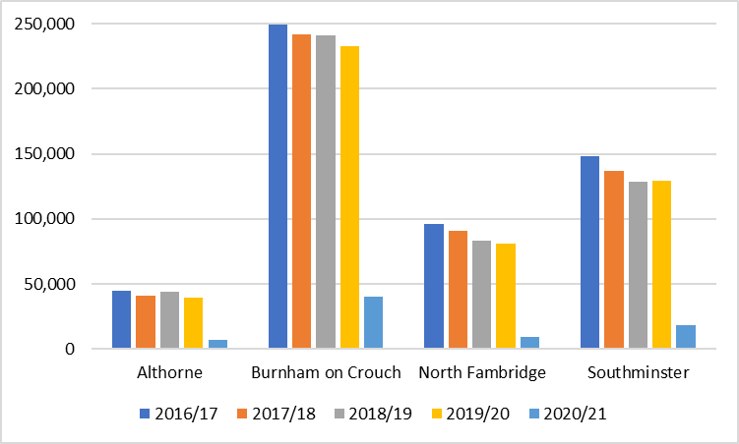
6.0 Conclusion
6.1 With regard to the natural environment and accessibility policies within the plan, in the main they are delivering as set out in the LDP on the Allocated Strategic Sites and Garden Suburbs. Prior to Covid-19 rail usage appeared to be declining on the Crouch Valley Line and consideration of this will need to be part of any review of the LDP.

More information: www.maldon.gov.uk This document is available in different formats on request

Outside the District, the stations of Witham, Hatfield Peverel, Kelvedon and Chelmsford on the Great Eastern Mainline provide access to the national network for residents, businesses and visitors.

