MALDON DISTRICT COUNCIL
INFRASTRUCTURE FUNDING STATEMENT
2024/2025
01st August 2025

Contents
1.0 Introduction 2
2.0 Section 106 Income for 2024/25 3
3.0 Section 106 Expenditure for 2024/25 4
4.0 Total Funding Negotiated, Received and Spent Since 1992 6
5.0 Affordable Homes 8
6.0 Governance 10

1.0 Introduction

1.1 Government guidance requires Maldon District Council, as a Local Planning Authority (LPA) to produce a yearly Infrastructure Funding Statement (IFS) not later than 31st December each year.
1.2 Planning Obligations, or S106 agreements are legal agreements entered into with developers and landowners to mitigate the impacts of a development proposal; they are also called Developer Contributions. Planning obligations can be agreed to mitigate the impact of unacceptable development to make it acceptable in planning terms. However, planning obligations must meet the following three legal tests if they are to constitute a reason to grant planning permission. They must be:
- necessary to make the development acceptable in planning terms; and
- directly related to the development; and
- fairly and reasonably related in scale and kind to the development.
1.3 LPAs can, in turn, decide whether to set a Community Infrastructure Levy (CIL) for their area, which is a fixed-charge levied on most new development to help fund identified infrastructure requirements. At the present time Maldon District Council does not operate a CIL Charging Schedule, so the IFS will only be reporting on S106 obligations.
1.4 Income from developer contributions is used to help fund the infrastructure needed alongside new development and this helps to maximise the benefits and opportunities from growth in the District. Infrastructure includes the delivery of affordable homes and other community facilities such as play parks, open space and youth facilities. The district also negotiates in conjunction with the Mid Essex NHS Integrated Care Partnership (formerly the Mid Essex NHS Clinical Commissioning Group) to achieve contributions towards health infrastructure improvements.
1.5 Essex County Council is responsible for collecting planning obligations for some of the other elements of the District’s infrastructure where it is legally responsible for their delivery such as:
- Early learning and primary schools
- Secondary schools
- Highway improvements
- Transport planning
- Improvements to cycling and walking routes – sometimes shared with Maldon District Council
Consequently, Essex County Council is responsible for producing its own IFS for anything which it collects funding for and spends directly.
1.6 For completeness, set out at Appendix B, are details of all the S106 agreements relating to Maldon District.

2.0 Section 106 Income for 2024/25

2.1 S106 agreement income is collected with a view to delivering Maldon District`s Infrastructure Delivery Plan, which accompanies the 2017 approved Maldon District Local Development Plan (LDP). The LDP can be found: www.maldon.gov.uk/ldp.
Set out below in Chart 1 and Table 1 is the total amount of funding received into the Council for the financial year 2024/25 broken down into its funding use. The total amount of funding in was £11,210.99.

Chart 1
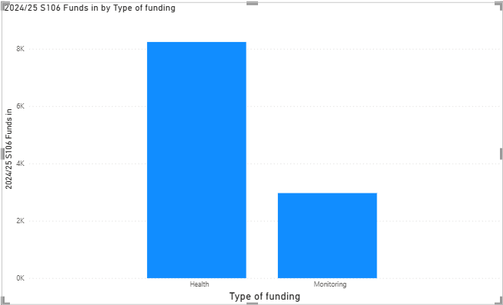
Table 1
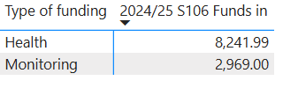

3.0 Section 106 Expenditure for 2024/25

3.1 The Council holds the funding from S106 agreements in reserves until it is either called for by a third-party organisation that needs it to invest in infrastructure within their control, or when the Council is in a position to spend the funding directly on that infrastructure, which would normally be when all the contributions have been collected. After the S106 legal agreement is signed when planning permission is granted, the Council does not have freedom over where this funding can be spent. The funding can only be spent on projects if they align with the terms of the relevant legal agreements.
Set out below in Chart 2 and Table 2 is the total amount of S106 funding spent during the financial year 2024/25
Chart 2
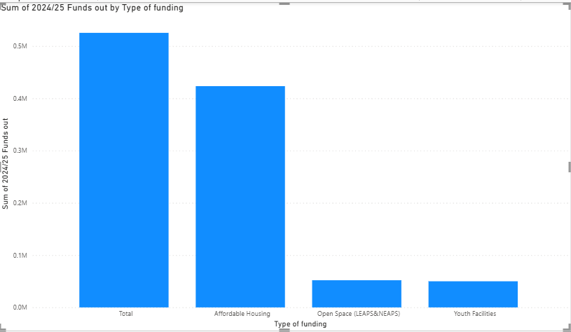
Table 2
Type of funding | 2024/25 Funds out
Affordable Housing | £423,453.56
Open Space (LEAPS&NEAPS) | £52,000.00
Youth Facilities | £50,000.00
Total | £525,453.56

3.2 Table 3 sets out the expenditure details of the funds have been expended in 2024/25.
Table 3
Type of Funding | Amount | Project
Affordable Housing Projects | £423,453.56 | These funds were spent on the purchase of Stephens House, Maldon for use as temporary housing accommodation.
Open Space (Leaps and Neaps) | £52,000.00 | To fund works on the Galleon Play area in Promenade Park, Maldon
Youth Facilities | £50,000.00 | Part of the funding to fund the Youth Facilities project in Maldon. A project which commenced in 2024/2025. Spend in 2025/2026 will be to complete the project and a project for Youth Facilities in Burnham on Crouch and West Maldon.
TOTAL | £525,453.56

4.0 Total Funding Negotiated, Received and Spent Since 1992

4.1 The Council has, since 1992, negotiated a substantial amount of funding through S106 agreements and this section sets out how much has been received, how much has been spent and how much funding is yet to be remitted into the Council. It also sets out for what purpose that funding has been used for.
Chart 3

Chart 4

Table 4
Type of funding | Amount Received | Amount Spent | Amount left to Remit
Affordable Housing | £906,951.72 | £896,951.72 | £47,199.00
Health | £885,593.07 | £52,861.44 | £1,035,820.04
Open Space | £23,440.00 | £23,440.00 | £0.00
Open Space (LEAPS&NEAPS) | £116,121.62 | £63,291.62 | £34,560.00
Open Space (SUDS) | £0.00 | £0.00 | £0.00
Open Space (Allotment) | £15,999.41 | £8,000.00 | £14,520.00
Open Space/Ecology | £49,808.45 | £49,808.45 | £0.00
Open Space (Sports) | £85,375.00 | £85,375.00 | £0.00
Monitoring Environment | £0.00 | £0.00 | £0.00
Ecology | £0.00 | £0.00 | £139,177.40
Cycle/Footway | £16,000.00 | £3,268.14 | £0.00
Youth Facilities | £940,815.30 | £87,450.91 | £184,033.09
Monitoring | £51,293.69 | £2,659.00 | £13,708.00
Legal Fees | £200.00 | £0.00 | £0.00
Parking | £255,000.00 | £255,000.00 | £0.00
TOTAL | £3,362,691.01 | £1,544,199.03 | £1,469,017.53

Refunded Funds
4.5 In the financial year 2024/25, the Council did not have to refund any funding to developers regarding S106 clauses going out of time.
Essex Coast Recreational Disturbance Avoidance and Mitigation Strategy (RAMS)
4.6 The Council also collects funding via S106 for the Essex Coast RAMs payments. The Strategy is a Supplementary Planning Document in the Maldon District (and elsewhere in Greater Essex) and it sets out a long-term strategic approach to lessen the impact of local housing development in Greater Essex on protected birds along the Essex coast. The Essex Coast RAMS aims to prevent bird and habitat disturbance from recreational activities. It does this through a series of mitigation measures, which encourage all coastal visitors to enjoy their visits responsibly. The fund is collected either via a S106 agreement or a legal deed called a Unilateral Undertaking (or UU) with all developers of new housing across Essex. A tariff is set every year and the funding is passed to Chelmsford City Council as the partnership administrator of the scheme on behalf of the partner local planning authorities.
Table 5 sets out the RAMs fees received, due and the spend since March 2021.
Table 5
RAMS | Due | Received
RAMS Fee Due | £262,005.28 | £58,020.67
RAMS Monitoring £50 | £7,550.00 | £3,970.00
TOTAL | £269,555.28 | £61,990.67
TOTAL SPEND |  | £44,068.68

For more information on the Essex Coast RAMS Strategy https://www.maldon.gov.uk/download/downloads/id/18981/rams_strategy.pdf

5.0 Affordable Homes

5.1 The Council’s approved LDP Policy H1 encourages developers of schemes of more than 10 unit or 1,000sqm to build between 25% and 40% of their development in the District as affordable homes. The actual percentage will depend on the specific location of the development in the district and the viability of the scheme in financial terms. The Council encourages the affordable homes to be delivered on the individual development sites wherever possible, where they can be dedicated to households that need them. In some circumstances, this may not be possible and then an agreed financially equivalent sum of money (the amount paid for an Affordable Unit that is of the greatest demand by the Local Housing Needs Assessment (formerly the Strategic Housing Market Assessment) at that point in time) may be paid as a contribution.
This important aspect of on-site provision represents a significant contribution to the number of new homes provided to meet the affordable housing need of the District.
What is meant by the term an “Affordable Home” is defined in the LDP and in the Annex 2 of the National Planning Policy Framework.
In the financial year 2024/25, the Council was informed that the following new affordable homes were delivered in the District:
Affordable Rented Homes 88
Intermediate/Shared Ownership Homes 54
Total Affordable Homes 142
5.2 The total number of housing completions in 2024/25 was 400. Therefore, the 142 affordable housing completions represents approx. 35.5% per cent of the total number of new homes completed for the same period. Chart 5 below shows the amount of housing delivered in relation to the amount of affordable housing delivered since 2021/22.
Chart 5

Chart 6 below shows the percentage of affordable housing delivered compared to market housing since 2021/22.

Chart 6
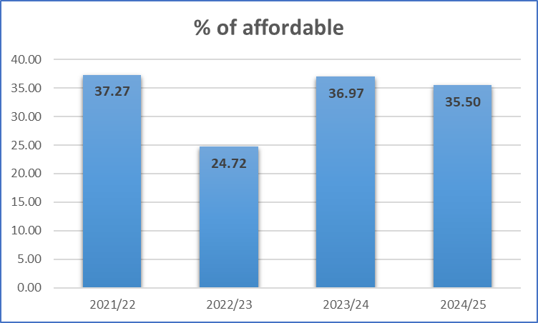

6.0 Governance

6.2 The Council continues to liaise with Essex County Council on the delivery of its infrastructure (primary and secondary schools’ expansion, early-years facilities, highways, etc.) to establish a better understanding of infrastructure upgrades and its project delivery timetables. This will not only provide a clearer picture of delivery but will assist in planning for new infrastructure within the LDP Review. Officers in general meet with ECC on a 6-weekly cycle and ensure that liaison is occurring when there is potential for combined or overlapping health and ECC infrastructure. Essex County Council produces its own Infrastructure Funding Statement, the details of which can be found on their website. www.essex.gov.uk/planning-land-and-recycling/planning-and-development/planning-advice-and-guidance/guidance
6.3 In 2024, the Council appointed a Project Manager to deliver youth facilities and Open Space Local Equipped Area for Play (LEAPs) in the District using S106 funding collected from various developments in Maldon and Burnham. This project is now starting to come forward and will be completed in 2025/26.
6.4 In the interests of transparency, alongside this IFS and available to download from our website, is an MSExcel spreadsheet of all the S106 agreements relating to the District. The spreadsheet sets out the funding due-in, received and spent and what each clause in the agreements relate to.

Via Section 278 Agreements (Highway Act 1980)
https://www.essex.gov.uk/planning-land-and-recycling/planning-and-development/planning-advice-and-guidance/guidance
https://www.maldon.gov.uk/info/7050/planning_policy/9810/infrastructure_delivery
Since the introduction of the Government’s First Homes Scheme in May 2021, the term may also include homes that are made available on the free market with a government subsidy for the first owners of new homes.

