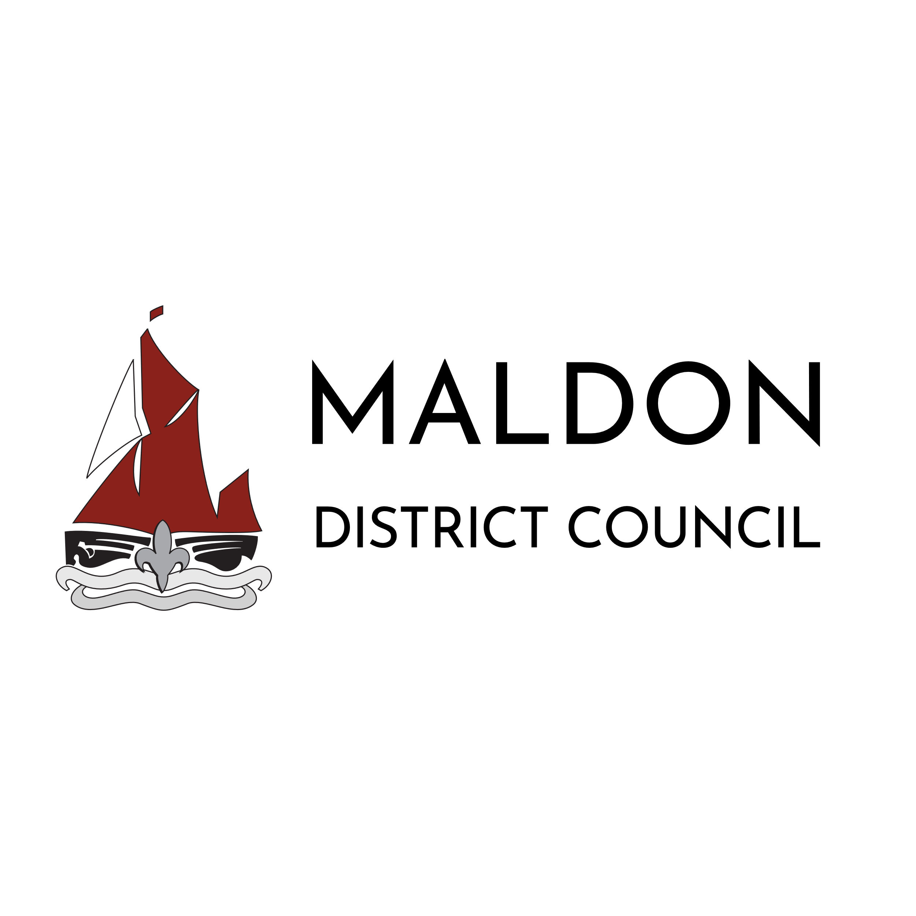
Modern Slavery and Human Trafficking Statement 2025- 26
This statement sets out what Maldon District Council is doing to understand and identify all potential modern slavery or human trafficking risks related to its business. It also identifies the steps Maldon District Council is taking to eliminate and prevent modern slavery and human trafficking both across the organisation and its supply chains.
Commitment
Maldon District Council as a public sector organisation, an employer and community leader is committed to undertaking a preventative approach to modern slavery and human trafficking within its corporate responsibilities and activities.
The Council has adopted the Modern Day Slavery Charter to reinforce its commitment to preventing Modern Slavery within its operations and supply chain.
Organisational Structure and Supply Chain
Maldon District Council provides a large range of services to over 65,000 residents within Essex. The majority of services delivered by the Council are directly managed and operated by Council staff and departments.
There is a clear requirement that, where services or goods delivered by the Council are provided in partnership with external organisations, those organisations must have and operate their own policies and practices in relation to modern slavery. This ensures alignment with the Council’s commitment to ethical procurement and safeguarding human rights across all supply chains and service delivery.
All suppliers taking part in Maldon District Council’s procurement processes must state whether they are a relevant commercial organisation, as defined by section 54 of the Modern Slavery Act 2015 (“the Act”). If they are, they are required to confirm their compliance with the annual reporting requirements contained within Section 54 of the Act. Failure to meet these requirements is treated as grounds for mandatory exclusion.
The above approach, adopted by Maldon District Council, is in line with that developed by Crown Commercial Services, the executive agency and trading fund of the Cabinet Office of the UK Government and is utilised nationally across the public sector. Maldon District Council has an expectation that any organisation with which it works, commissions or procures a service from, operates appropriate policies and practices in relation to modern slavery and human trafficking.

Our Responsibilities
Maldon District Council has a corporate crosscutting role as an employer, community leader and procurer with responsibility to safeguard people within our communities across all our operations. Maldon District Council works with Essex Police and other enforcement agencies as appropriate to share intelligence and work collaboratively to address issues relating to modern slavery or human trafficking.
Our Policies
As a Council, there are a wide range of policies and processes in place that reflect our commitment to prevent modern slavery and human trafficking in everything that we do.
All policies are subject to a robust assurance process and are subject to staff and trade union consultation. Councillors, senior officers and partner organisations may also be invited to comment.
Relevant Policies:
• Employee Code of Conduct
• Whistleblowing Policy and Procedure
• Equality, Diversity and Inclusion Policy
• Safer Recruitment Policy
• Safeguarding Children, Young People and Adults Policy
• Domestic Abuse Workplace Policy
• Contract Procedure Rules
Multi-Agency Arrangements
The Essex Safeguarding Adults Board (ESAB) is a statutory organisation that is committed to protecting an adult’s right to live in safety, free from abuse and neglect. It collaborates with wider strategic partnerships in Essex to ensure that where safeguarding responsibilities spread across the organisations, there is a clear understanding of where responsibility lies or a robust joined-up approach.
The Essex Safeguarding Children Board (ESCB) is a statutory body which acts as a mechanism for agreeing how relevant organisations in Essex co-operate to safeguard and promote the welfare of children and young people.
As part of the Council’s commitment to robust safeguarding provision, Maldon District Council has a board member on both the ESCB and the ESAB.
Maldon and all its partners strive to work towards a slavery-free town through developing community resilience to modern slavery and human trafficking. This will be done through facilitating partnership work, raising awareness, developing and delivering training and safeguarding resources, community intelligence gathering and disruption tactics to promote effective survivor care.
Management Responsibilities
The Council has responsibilities to its workforce, this includes employee health, safety and welfare.
As part of this commitment, the Council recognises that modern slavery can affect individuals in both direct and indirect ways, including through coercion, exploitation, or abuse in the workplace.
Employees are encouraged to raise any concerns they may have, including suspicions or experiences related to modern slavery. The Council guarantees that such concerns will be taken seriously, investigated appropriately, and handled with confidentiality and sensitivity.
To support staff, the Council provides access to an Employee Assistance Programme (EAP), offering 24-hour confidential support, 365 days a year. This service includes guidance and counselling for work-related and personal issues, including support for victims of crime and exploitation. The EAP is a vital resource in helping employees feel safe, supported, and empowered to speak out against any form of abuse or unethical practice.
Training and Awareness Raising
To meet its statutory safeguarding responsibilities, the Council offers a wide and extensive training programme to staff across all services.
Safeguarding training sessions have been delivered by the Chelmsford City Council to a wide range of staff, elected members and key partners. The Chelmsford City Council’s level 2 and level 3 safeguarding training provides awareness of Modern Day Slavery and Human Trafficking matters within its programme.
Officers of the Council who serve as Safeguarding Leads and Designated Safeguarding Reporting Officers (DSRO’s) within the Internal Safeguarding Review Board are expected to maintain and enhance their professional knowledge and competencies. They actively pursue opportunities for continued professional development in safeguarding practice, legislation, and emerging issues—such as modern slavery—whenever such opportunities arise. This commitment ensures that the Council’s safeguarding responsibilities are met with up-to-date expertise and informed decision-making.
Key messaging will continue throughout the year via our internal communication mechanisms and social media platforms.
If any staff witness or suspect modern slavery or human trafficking is taking place, they can follow the internal safeguarding reporting process which is found HERE.
In line with statutory responsibilities and related guidance for local authorities it may be required to notify the Home Office of a potential victim of modern slavery or human trafficking or make appropriate referrals to the National Referral Mechanism (NRM) for all children and consenting adults.
Due Diligence
Maldon District Council is committed to and understands the vital role that procurement plays in this function. This includes due consideration and recognition of its duty when sourcing services and supplies to ensure that effective employment practices are in place within the supply chain and that modern slavery and human trafficking practices will not be tolerated.
Due diligence actions must be always carried out. The contract rules require collaboration with the Procurement Team for high value and high-risk procurements to ensure, before awarding any contracts to prospective bidders, the Council meets its legal obligations under the Modern Slavery Act 2015, and the Contract Procedure Rules 2015.
Declaration
This statement is made pursuant to Section 54 (1) of the Modern Slavery Act 2015 and constitutes Maldon District Council’s slavery and human trafficking statement for the term of the financial period.
Doug Wilkinson, Chief Executive
Councillor Richard Siddall, Leader of the Council

