Headline evidence for public consultation
Maldon District Housing, Homelessness and Rough Sleeping Strategy 2026–2031

About this evidence summary
This document summarises the headline evidence being used to develop Maldon District Council's Housing, Homelessness and Rough Sleeping Strategy. It is intended to help residents, partners and other interested people respond to the public consultation.
It is not the Council's statutory Homelessness Review. The full review and detailed evidence base will support the final strategy and will contain fuller analysis of housing need, homelessness, services, resources and future demand.
The figures in this summary come from national statistics, Council records and local studies. They use different dates and reporting bases. Projections are planning estimates rather than forecasts of exactly what will happen.

The central issue
Housing and homelessness form part of the same system. Preventing homelessness depends, in large part, on whether people can find and retain a suitable and affordable home. Decisions about housing supply, tenure, standards and access directly affect homelessness and demand for local services.
In Maldon, high house prices relative to local earnings, a comparatively limited supply of social rented housing and uneven access to services across more remote rural areas restrict the options available when a household's needs or circumstances change.
Affordability is therefore a thread running through demand for homelessness services, the ability to prevent homelessness and the availability of settled move-on options.

Maldon at a glance
Indicator | Latest position | Why it matters
Population | 70,196 in 2025 | A larger population increases overall housing demand
Residents aged 65 or over | 25.0% in 2021 | Need for accessible homes adaptations and suitable downsizing options
Median house price | £385,000 in the year to September 2025 | £85,000 above the England median
Housing affordability | 11.05 times median earnings | Buying is beyond the short term reach of many households on local wages
Initial homelessness assessments | 250 in 2025/26 | The highest number in the six year series
Temporary accommodation | 41 households at 31 March 2026 | More than half were placed outside the district, potentially disrupting access to local services and support networks

Sources: ONS, MHCLG and Maldon District Council records. Dates vary by indicator and are shown throughout this summary.

A growing and ageing district
Maldon is a geographically large, mainly rural district. Maldon, Heybridge and Burnham-on-Crouch are the main centres, while many residents live in smaller communities where public transport and access to services are more limited. A home that is affordable on paper may not be suitable for someone who needs regular care, cannot drive or relies on a local support network.
Indicator | Current position | Projected position in 2036
Resident population | 70,196 in 2025 | 76,019
Households | 27,900 in 2021 | 33,360
Residents aged 65 or over | 25.0% in 2021 | 29.5%
Residents aged 75 or over | 11.6% in 2021 | 15.2%

The population grew by 7.8% between 2020 and 2025, almost twice the 4.0% increase across England. Household numbers are projected to rise faster than the population, increasing by 19.6% between 2021 and 2036.
This changes the types of homes required. Maldon will need accessible mainstream housing, adaptations to existing homes, smaller homes that allow older residents to remain in their communities, and purpose-built housing for people who need care or support.

The homes people live in
Tenure in 2021 | Maldon | England
Owner occupied | 77.0% | 62.3%
Private rented | 11.8% | 20.3%
Social rented | 11.2% | 17.1%

High home ownership provides stability for many households, but the smaller private and social rented sectors leave less choice for people who cannot buy or whose circumstances change. Around 69% of homes have three or more bedrooms, compared with 61% across England. More smaller and accessible homes could widen choice and allow some larger properties to become available over time.
Sources: ONS Census 2021, mid-year estimates and 2022-based population and household projections.

Affordability is the clearest pressure
In the year to September 2025, the median house price in Maldon was £385,000. The median home cost 11.05 times median full-time workplace earnings, compared with 7.6 times across England. Even a lower-quartile home cost £310,000, £42,000 more than in 2020.
Average private rents are lower than the England average, but they have risen and are above Local Housing Allowance rates across the property sizes shown below. Local Housing Allowance is the maximum amount used to help calculate Housing Benefit or the housing element of Universal Credit for many private renters.
Property size | Modelled Maldon monthly rent June 2026 | Chelmsford monthly LHA | Colchester monthly LHA
1 bedroom | £802 | £793 | £623
2 bedrooms | £1,040 | £947 | £793
3 bedrooms | £1,253 | £1,197 | £972
4 or more bedrooms | £1,919 | £1,446 | £1,247

Source: ONS private rental statistics and Valuation Office Agency Local Housing Allowance rates. Rents are modelled estimates, not advertised-rent medians. LHA areas do not follow the district boundary exactly.

Housing supply and affordable housing
The district's housing stock grew from 29,151 homes in March 2021 to 30,720 in March 2025. In 2024/25, 400 net additional homes were delivered. This was 70% of the monitoring requirement for that year. National monitoring recorded 190 gross affordable additions across all affordable tenures in 2024/25, although annual delivery can vary sharply as larger developments are completed.
The 2025 Local Housing Needs Assessment estimated an annual need for 284 affordable homes as part of overall housing delivery. Of these, 203 were needed for households unable to afford private rent and 82 for affordable home ownership, with rounding accounting for the difference. The assessment recommended that most affordable provision should be rented, subject to viability. Recent growth has not removed the affordability gap, so the mix and tenure of new homes matter as much as overall supply.
The latest Council housing-register extract contained 735 active households. The median time in a household's current band was 14.1 months, and almost one third had been in the same band for at least two years.

Specific housing needs
The Local Housing Needs Assessment estimates that by 2044 the district will need 828 retirement or sheltered homes, 500 extra-care homes, 202 care bedspaces and 291 wheelchair-user homes. These are planning estimates, not targets for this strategy period, but they show the scale and direction of future need. Timely adaptations to existing homes will remain equally relevant because most older and disabled residents will continue to live in their current homes.

Demand for homelessness services
Homelessness is not limited to rough sleeping. It includes people who have no accommodation, cannot legally remain where they are living, or cannot reasonably be expected to continue living there. It also includes eligible households threatened with homelessness.
Across 2025/26, the Council completed 250 initial homelessness assessments. It owed a prevention duty to 91 households threatened with homelessness, a relief duty to 95 households already homeless, and accepted a main housing duty for 57 households. These are different stages in the statutory process and should not be added together as separate households.
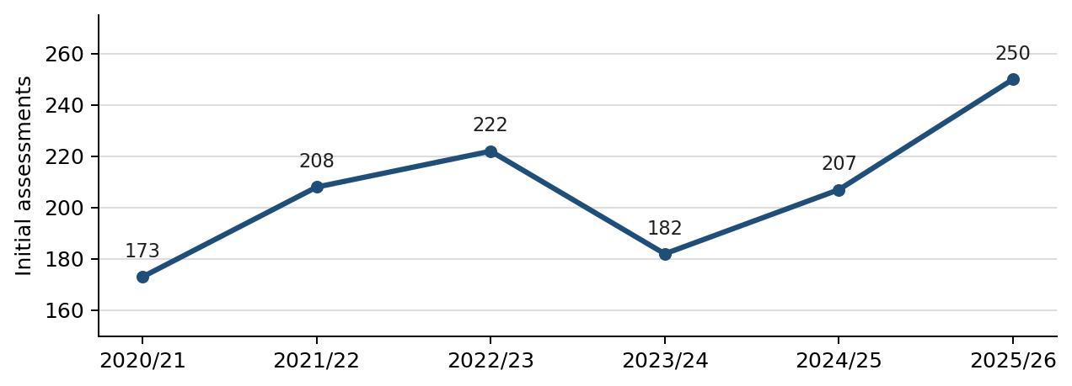
Source: MHCLG statutory homelessness statistics and Maldon District Council data. The 2024/25 total combines a locally generated first-quarter extract with published data for the remaining nine months.
The latest total is the highest in the six-year series and 20.8% above 2024/25. If assessments rose only in line with projected household growth, the total would reach about 265 by 2030/31. This is a planning baseline, not a forecast. Affordability, prevention work, housing supply and policy changes could all alter demand.

Why households lose their homes
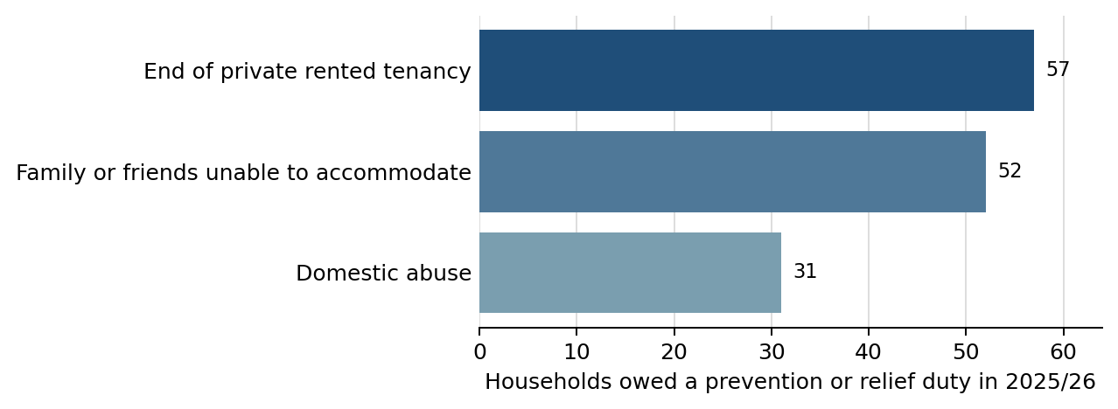
These three causes accounted for three quarters of the 186 prevention and relief duties owed in 2025/26. Each requires a different response: work with tenants and landlords, planned moves or mediation when informal arrangements break down, and a safe specialist response to domestic abuse.

Who needs help
There is no single typical household experiencing homelessness. Of the 186 households owed a prevention or relief duty in 2025/26, 104 were single adults and 65 were families with children. This included 40 lone-parent families and 25 couples with children. Thirty-one main applicants were aged 16 to 24 and 22 were aged 65 or over.
Support needs are common and often overlap. At least one support need was recorded for 160 households, with 317 individual needs recorded in total.
Recorded support need | Households in 2025/26
Mental health | 104
Physical ill health or disability | 74
Domestic abuse | 31

Some households had more than one recorded need, so the figures should not be added together. Housing alone cannot resolve every support need, but support is much harder to sustain without somewhere safe and suitable to live.

Prevention relief and moving on
Of the 227 prevention and relief duties that ended in 2025/26, 87 ended with accommodation secured, a combined rate of 38.3%. This should not be read as a simple pass or fail rate. Duties also end because a household moves into the main housing duty, contact is lost, an application is withdrawn or eligibility changes.
Council move-on information shows that both social and private rented homes are being used. For cases grouped by the date of their original approach, 45 households moved into social housing during 2025/26 and 53 secured private rented accommodation. Ten moved into supported accommodation and 12 went to family or friends.
A fuller picture will require consistent measures of repeat homelessness, loss of contact and whether accommodation is sustained. These will be addressed in the statutory review and delivery arrangements rather than inferred from the headline figures.

Temporary accommodation and out-of-district placements
Temporary accommodation is an essential safety net, but it is not a settled home. At 31 March 2026, 41 households were living in temporary accommodation, compared with 39 a year earlier.
Temporary accommodation indicator | Position at 31 March 2026
Households in temporary accommodation | 41
Households with children | 24
Nightly-paid self-contained accommodation | 31
Registered Provider stock | 10
Placed outside Maldon District | 21
In bed and breakfast accommodation | 0

During 2025/26 the Council recorded 137 placement episodes, of which 116 were in nightly-paid self-contained accommodation and 97 were outside the district. These are placement episodes, not unique households, so a household that moved between placements may be counted more than once.
Out-of-district placements may sometimes be necessary when suitable local accommodation is unavailable, but they can make it harder for households to maintain access to schools, employment, care, health services and family or community support. This can be particularly disruptive for families with children and people with support needs.
Twenty-four of the 41 households in temporary accommodation at 31 March 2026 had been there for less than six months. Ten had been there for between six months and one year, five for between one and two years, and two for between two and five years. These are current stays measured at one date, not completed placement durations.
The absence of households in bed and breakfast accommodation at the snapshot date is a positive position. The wider figures show that pressure has shifted towards nightly-paid self-contained accommodation, often outside Maldon, rather than disappeared.

Rough sleeping
The autumn rough sleeping snapshot estimated that three people were sleeping rough in Maldon District in 2025, the same as in 2024 and up from none in 2023. Monthly management information recorded one person sleeping rough long-term in December 2025.
A single-night snapshot cannot capture every person sleeping rough. In a large rural and coastal district, people may be less visible, sleep in vehicles or isolated sites, or move between rough sleeping and insecure arrangements with friends. Local intelligence from outreach, health, police and community organisations remains important.

What the evidence suggests
The pressures described in this summary reinforce one another. High purchase prices keep some households in private renting for longer. Rising rents make tenancies harder to secure and sustain. Limited social housing restricts move-on. A shortage of smaller and accessible homes reduces movement within the existing stock.
The evidence raises five main issues for the strategy and for this consultation:
- how the Council and its partners can identify housing risk earlier, particularly where a private tenancy is ending, arrangements with family or friends are breaking down, or domestic abuse is present
- how to ensure housing growth delivers more rented homes that are affordable to households on local incomes, alongside smaller and accessible homes and suitable family housing
- how to make better use of existing homes through adaptations, nominations, tenancy sustainment, landlord engagement and proportionate action on empty or poor-quality homes
- how to reduce reliance on nightly-paid and out-of-district temporary accommodation, limit disruption to households’ local connections and maintain the strong position on avoiding bed and breakfast use
- how housing, health, care, domestic abuse and other services can work more clearly around the resident, with shared evidence and accountability
Maldon District Council is a non-stock-holding authority, so it does not own the district's social housing. It can act directly in some areas, including homelessness services, housing standards and Disabled Facilities Grants. Many outcomes depend on its planning, enabling and convening roles and on sustained work with Registered Providers, developers, Essex County Council, health services and community organisations.
Your consultation response will help the Council test whether these are the right issues, understand how they affect different people and places, and decide where the strategy should focus.

How the figures should be read
- Percentages and totals may use different populations and reporting periods. They should not be combined unless the text says they can be.
- Homelessness duties describe stages in the legal process. The same household may move through more than one stage.
- Temporary accommodation placement figures count episodes, while the snapshot counts households present on one date.
- Population and housing-need projections are planning estimates. They are not exact predictions or delivery targets.

Sources
Principal published sources are listed below. Datasets and the detailed methodology will be documented in the full evidence base and statutory Homelessness Review.
- Office for National Statistics local indicators for Maldon: Population, age, housing and local comparisons.
- Office for National Statistics Housing affordability in England and Wales 2025: House prices, earnings and affordability ratios.
- Maldon Local Housing Needs Assessment Update September 2025: Overall and affordable housing need, tenure and specialist housing estimates.
- Maldon five year housing land supply calculation February 2026: Housing requirement and deliverable land supply.
- MHCLG Statutory homelessness in England January to March 2026: Assessments, duties, outcomes, reasons, household characteristics and temporary accommodation.
- MHCLG Affordable housing supply in England 2024 to 2025: Affordable housing additions by tenure.
- MHCLG Rough sleeping snapshot in England autumn 2025: Estimated people sleeping rough on a single night.

Council and local evidence
- Maldon District Council housing register extract
- Maldon District Council homelessness and temporary accommodation records
- Maldon District Council Data Aggregate September 2026
- Maldon District Gypsy and Traveller Accommodation Assessment September 2024
- Council service capacity and finance returns August 2026
Data was compiled during 2026. Figures may be updated before the strategy and statutory Homelessness Review are finalised.

